**Year 2**

**History Topic: BHM - Florence Nightingale and Mary Seacole**

**Seamer and Irton CP School – Knowledge Organiser**

**What’s next?**

BHM – Significant events – Year 3 – An introduction to Black History Month

**Prior Knowledge**

**ELG** - Know some similarities and differences between things in the past and now, drawing on their experiences and what has been read in class.

**BHM** - Significant people and events – Year 1 – Mae C Jemison

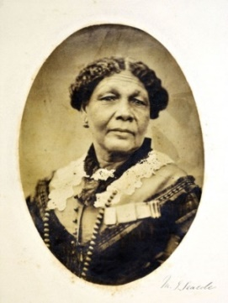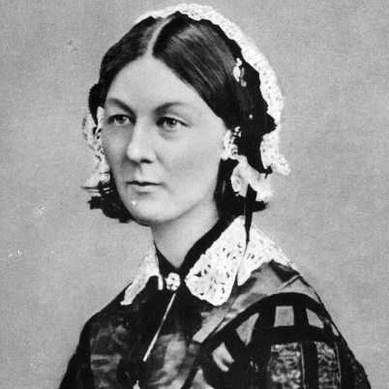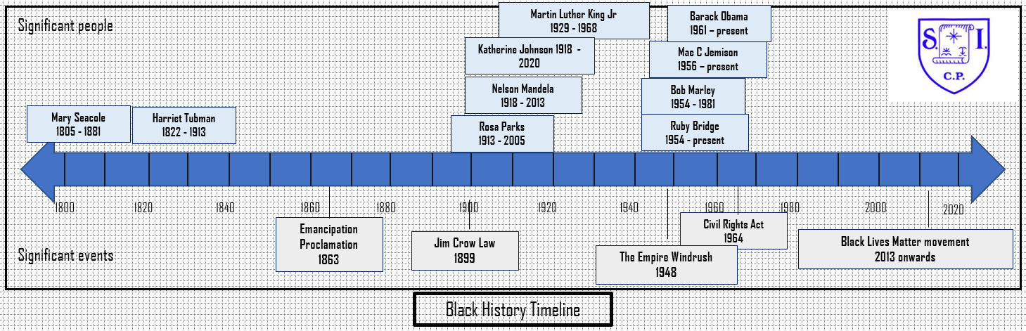

**Key Knowledge I need to understand**

The Crimean War was fought from

October 1853 – February 1856

It was fought in the Crimea, an area in the south of Russia at the time (now part of Ukraine). On one side were Britain, France, and Turkey, and on the other side was Russia.

Florence Nightingale 1820 – 1910

The nurse Florence Nightingale went to the Crimea to take care of the soldiers. She introduced modern nursing practices and saved many lives.

Mary Seacole 1805 – 1881

Mary Seacole is a significant figure in the history of nursing. In 1855, she travelled from Jamaica to the Crimea to help care for British soldiers wounded in the Crimean war.

Because of the colour of her skin, Mary Seacole had to overcome racial prejudice against her to carry out her work as a nurse outside of Jamaica.

**Key vocabulary I need to know**

Germs

Medicines

Patient

Lady of the lamp

Mother Seacole

Race

Racism

**How I will show what I have learned?**

I can explain what makes a person significant.

I can explain how Florence Nightingale improved nursing.

I can explain who Mary Seacole was and how she improved

nursing

I can compare the lives of different nurses (why was Nightingale’s story told more than Seacole’s?)

I can understand what racism is

I can persuade others to remember Florence Nightingale and Mary Seacole